Name: Period: Date:

RIGHT TRIANGLE DEFINITION OF TRIGONOMETRIC FUNCTIONS
Guided Notes
Warm-Up:
Find the missing side of the triangle.
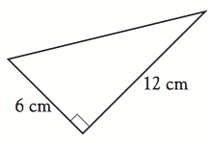

Answer: √180 or 6√5
How did you solve this problem? Used Pythagorean Theorem
Triangle Basics
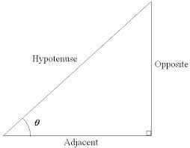

- Hypotenuse: the longest side of a right triangle; is opposite the right angle.
- Opposite Leg: the side of the right triangle that is opposite the given angle.
- Adjacent Leg: the side of the right triangle that is next to the given angle.
Label the correct sides of the triangle
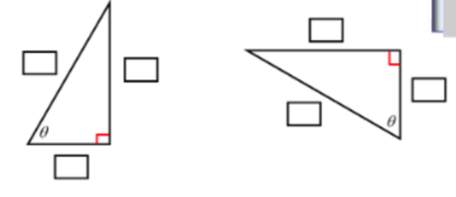
Show formula for SOH CAH TOA

SOH: sin θ = opposite/hypotenuse
CAH: cos θ = adjacent/hypotenuse
TOA: tan θ = opposite/adjacent
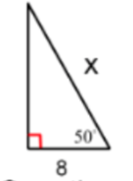
How is this problem different from the warm-up problem?

Partner Share: How would you solve this problem?

What are YOUR ideas?

Let’s Try It!

Show Your Work!
The six trigonometric functions of θ are defined as follows.

Sine (θ) = sin θ = opp/hyp Cosecant (θ) = csc θ = hyp/opp

Cosine (θ) = cos θ = adj/hyp Secant (θ) = sec θ = hyp/adj

Tangent (θ) = tan θ = opp/adj Cotangent (θ) = cot θ = adj/opp
Example One)
Evaluate the Six Trigonometric Functions of the angle C shown in the right triangle.

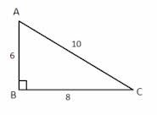

sin C = opp/hyp = 6/10 = 3/5 csc C = hyp/opp = 5/3

cos C = adj/hyp = 8/10 = 4/5 sec C = hyp/adj = 5/4

tan C = opp/adj = 6/8 = 3/4 cot C = adj/opp = 4/3

