Name: Period: Date:

Homework Packet

Find the missing side.

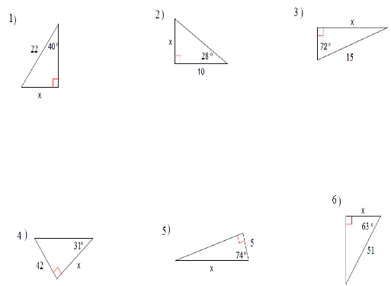

Find the missing angle.

Use the given trigonometric function value of the acute angle to find the exact values of the five remaining trigonometric function values.

9. sin θ = 4/5

10. tan θ = 3

11. cos θ = 5/9

12. cot θ = 5

13. sec θ = 9/2

14. csc θ = 6

15. Brad built a snowboarding ramp with a height of 3.5 feet and an 18° incline. Draw a diagram to represent the situation. Determine the length of the ramp.

16. Traffic is detoured from Elwood Ave., left 0.8 mile on Maple St., and then right on Oak St., which intersects Elwood Ave. at a 32° angle. Draw a Diagram to represent the situation. Determine the length of Elwood Ave. that is detoured.

Solve each triangle.
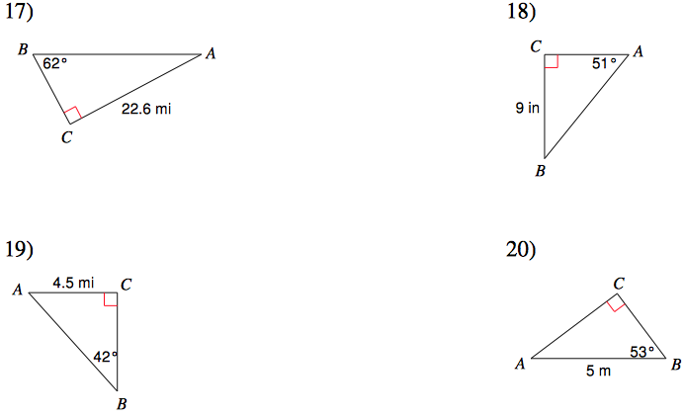

CHALLENGE PROBLEMS: (Optional)
- Prove that if θ is an acute angle of a right triangle then tan θ = sinθ/cosθ and cot θ = cosθ/sinθ.

- Jason and Nadina know the value of sinθ=a, and are asked to find cscθ. Jason says that this is not possible, but Nadina disagrees. Is either of them correct? Explain your reasoning.

Answer Key:
1. 14.14
2. 5.32
3. 14.27
4. 69.90
5. 18.14
6. 23.15
7. 66.4°
8. 45°
9. cos θ=3/5; tan θ=4/3; csc θ=5/4; sec θ=5/3; cot θ=3/4
10. sin θ=3√10/10; cos θ=√10/10; csc θ=√10/3; sec θ=√10; cot θ=1/3
11. sin θ=2√14/9; tan θ=2√14/5; csc θ=9√14/28; sec θ=9/5 cot θ=5√14/28
12. sin θ=√26/26; cos θ=5√26/26; tan θ=1/5; csc θ=√26; sec θ=√26/5
13. sin θ=√77/9; cos θ=2/9; tan θ=√77/2; csc θ=9√77/77; cot θ=2√77/77
14. sin θ=1/6; cos θ=√35/6; tan θ=√35/35; sec θ=6√35/35 cot θ=√35
15. 11.3ft
16. 1.3 mi
17. AB=25.6, BC=12, A=28°
18. AC=7.3, AB=11.6, B=39°
19. AB=6.7, BC=5, A=48°
20. AC=4, BC=3, A=37°

