Name: Period: Date:

Trigonometric Mini Golf

Objective: The students will use their knowledge on the trigonometric rations to calculate unknown lengths and sides in various arrangements of triangles.

Materials:
- Golf Hole Packet
- Dry Erase Marker
- Overhead sheet
- Protractor
- Ruler
- Wipe
- Graphing Calculator

Directions:
- Get with your partner and collect your materials.
- For each Hole:
- Using the dry erase marker and overhead sheet, draw the shortest distance.
- When you think you found the shortest distance, trace the line onto the paper.
- Calculate the distance.
- Segment path into right triangles.
- Measure and record the lengths of each leg with your ruler.
- Use trigonometric functions and rations to solve for every right triangle and record your answers.

Hole One:
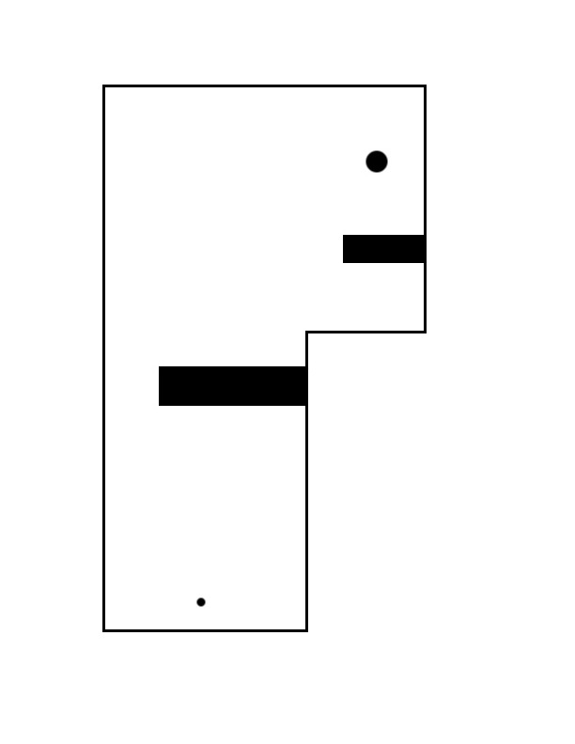

Hole Two:

Hole Three:
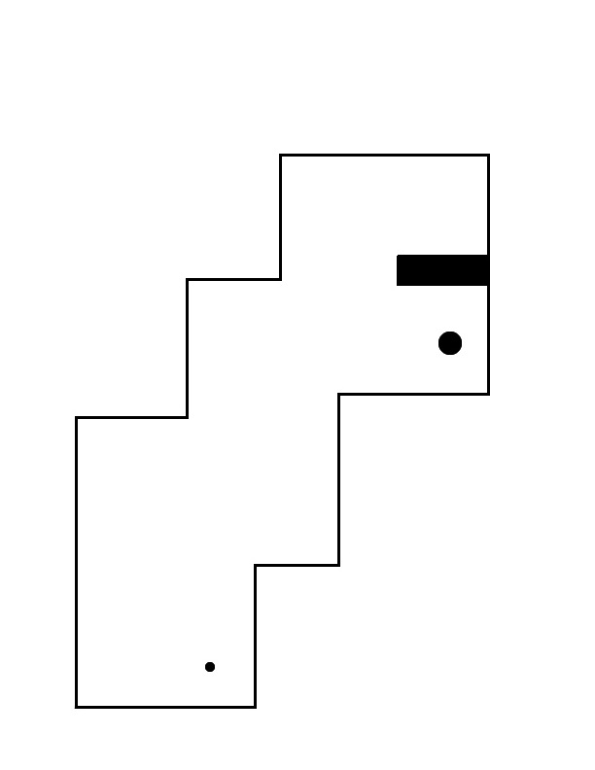

Hole Four:
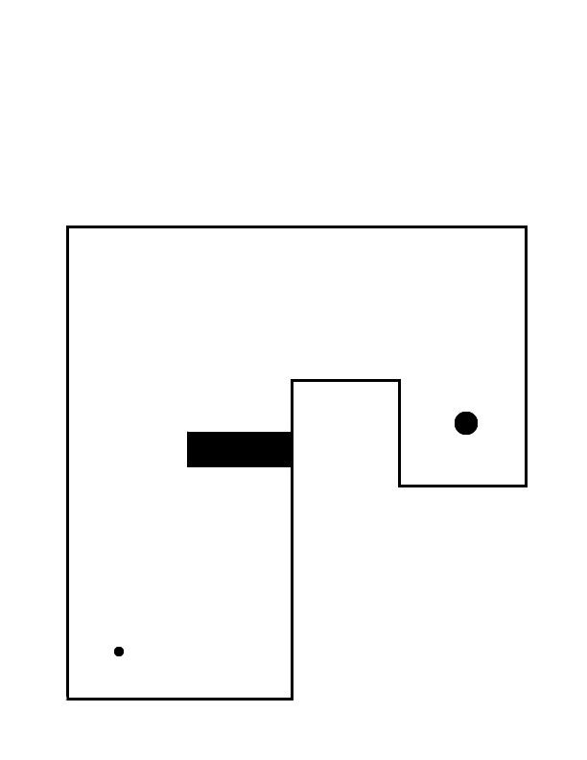

Here is an example:
