Name: Period: Date:

Pre-Assessment Quiz

Find the missing value in each figure.

1. 2.

6cm c c 5 cm

3 cm 12 cm

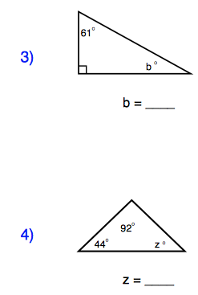

Determine whether each of the following could represent the measures of three sides of a triangle. Write yes or no.

5. 4, 8, 12

6. 12, 15, 18

7. The sides of a triangle have lengths x, x+17, and 25. If the length of the longest side is 25, what value of x makes the triangle a right triangle?

Answer Key:
1. √45 or 3√5
2. 13
3. 29°
4. 44°
5. No
6. Yes
7. 7

